24th July 2017

**YOKOHAMA Now Also Chelsea FC Sleeve Sponsor**

YOKOHAMA agreed on 21st July with England’s Chelsea Football Club to be a jersey shirt sleeve sponsor for the 2017–2018 season. The agreement expands on YOKOHAMA’s ongoing official partnership with the current Premier League champion. In addition to the YOKOHAMA TYRES logo that has been prominently featured across the chest of the Chelsea FC jersey these past two seasons, the new jerseys to be worn by players during Premier League, FA Cup and Carabao Cup matches will feature the logo of the Company’s new ALLIANCE TYRES brand on the jersey’s left sleeve. The new jersey made its debut at Chelsea’s pre-season match with Arsenal at Beijing’s National Stadium (aka the Bird’s Nest) on 22nd July.

ALLIANCE is a new passenger vehicle tyre brand to be launched by Yokohama Rubber in Europe as a start in 2017. By adding the ALLIANCE brand to its YOKOHAMA brand, YOKOHAMA expects to better meet the needs of a broader and more diverse customer base for passenger vehicle tyres. The Alliance Tire Group (ATG), an off-highway tyre specialist that was acquired by Yokohama Rubber in July 2016, continues to expand its business in the markets for agricultural and construction machinery under the ALLIANCE brand.

Seeking to expand its global tyre sales and brand recognition, YOKOHAMA in July 2015 entered into a five-year partnership agreement with Chelsea FC, which has an extensive worldwide fan base. YOKOHAMA expects the partnership with Chelsea FC, which last season recaptured the Premier League title, to increase the brand recognition for its YOKOHAMA and ALLIANCE brands by appealing to images associated with the Champions.

Founded in 1905, Chelsea FC is one of the Premier League's most prestigious clubs. The Blues have captured the league title six times and won seven FA Cups. Chelsea also has won two UEFA Cup Winners' Cups, the UEFA Champions League in 2012, and the UEFA Europa League in 2013, making it the first U.K. club to win all three of the UEFA’s major club competitions.

Yokohama Rubber is a comprehensive global tyre and rubber manufacturer headquartered in Tokyo. Founded in Japan in 1917, the Company is commemorating its 100th anniversary this year. In addition to being a comprehensive maker of tyres, including tyres for passenger cars, trucks and buses, and construction machinery, Yokohama Rubber produces and markets a wide range of rubber products, such as automotive hoses and conveyor belts as well as marine hoses (MB products). The Company operates 18 tyre plants in nine countries around the world and 14 MB plants in eight countries and employs about 25,000 people globally. Its consolidated sales in fiscal year 2016 (ending 31st December 2016) totalled ¥596.2 billion.

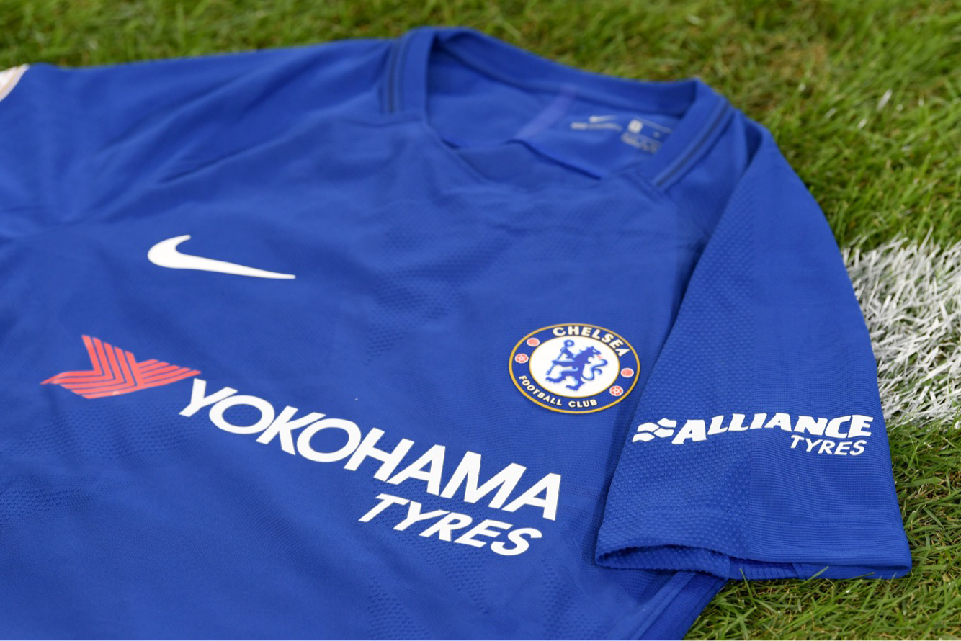

*The new jersey*



*The debut match of the new jerseys (vs. Arsenal on 22nd July)*